Using tags and rubrics to improve JUICE Search

Contents

Overview 1

Searchable attributes 3

Weighting and relevance calculations 4

Testing and analyzing search results 4

View search results with their weights and sort order 5

View searchable attributes for a set of search results 5

Improving Search results 6

Using tags to improve search results 6

Removing words that give unexpected results 7

Rubrics 7

Projects and Goals 7

Tools for reviewing user search requests 8

Adding and removing content items from Search 9

# Overview

When a user enters a word or phrase into the search field in JUICE, JUICE uses MongoDB’s search algorithm to find and display modules, modulettes (mini-lessons), and ancillary files with searchable attributes that contain the word or phrase.

Search results are grouped by module—a modulette or ancillary file will be listed underneath its parent module, even if the module itself is not found—and sorted by relevance.

* The most relevant modulette in each module will be listed separately from the rest of the modulettes at the top of the list.
* The rest of the modulettes will be listed in order of relevance unless they are equally relevant. Then they will be listed in the order they appear in the site.
* Ancillary files are listed underneath the modulette list, and are also listed by relevance:

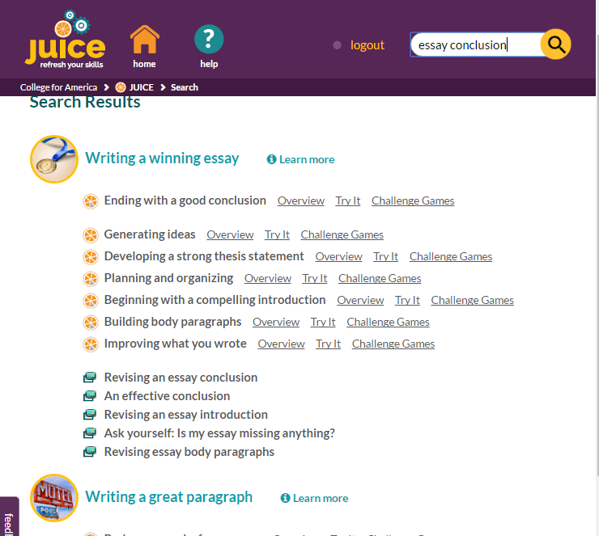

Modules, modulettes, and ancillary files that are eligible for display in search results and their attributes are stored in 3 collections in MongoDB:

search_ancillary_files

search_modules

search_modulettes

These collections contain content from the core JUICE content library.

Search results can seem unexpected for a few reasons:

* Search determines the “roots” of words and then finds words with the same root that matches. For example, a search on “Rounding” will also return “year-round school” as a match, although the relevance of the match will be much lower.
* An item may not have the search term in its searchable attributes. For example, the modulette “Generating ideas” does not have the word “essay” in its searchable attributes.
* An item may have an unexpected search term in its searchable attributes. For example, the modulette “Writing math expressions” would be returned for a search on “writing.”
* An item’s relevance may be higher than expected because two of its attributes match the search.

There is no end-user editing interface for modifying search attributes unless you set up the CAMPER content management system. However, you can manually modify the searchable attributes for any item in the MongoDB search collections to refine the search results.

If you add or remove content items from the site, you must update the MongoDB search collections to add or remove the content items and their attributes.

# Searchable attributes

Modules, modulettes, and ancillary files each have different searchable attributes. The searchable attributes for each item are as follows:

|  |  |
| --- | --- |
| **Item type** | **Searchable attributes** |
| Modules | Title |
| tags |
| rubrics |
| project names |
| goal names |
| Modulettes (mini-lessons) | Title (or name if title does not exist) |
| Title of group that the modulette belongs to |
| tags |
| rubrics |
| Ancillary files | Title |
| description |
| tags |

Content from the core JUICE library will have a complete set of searchable attributes including the original set of goals and projects for which the content was created.

Some of the attributes may appear to be missing words. For example, the title of the mini-lesson *Writing math expressions* will be listed as *math expressions*. Words that will return unexpected results have been removed from the search attributes.

If you add content to JUICE, you will need to update the MongoDB search tables manually with all the attributes you would like users to be able to search on. There is no end-user interface for editing Search attributes unless you set up the CAMPER content management system.

# Weighting and relevance calculations

The weighting and relevance of a search result is determined by a combination of relevance calculations carried out by MongoDB’s search algorithm using weights assigned to each attribute by JUICE.

JUICE weights tags more heavily than other attributes. The weights assigned by JUICE are as follows:

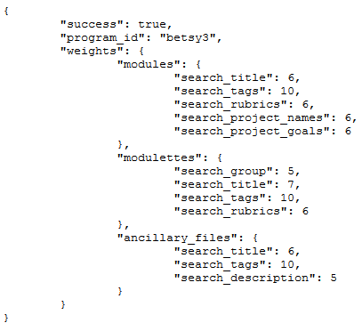

Other than the weighting, JUICE has no control over the behavior of Search and the relevance calculations!

# Testing and analyzing search results

The best way to see if Search is behaving as you expect is to try different search terms and see what the results are.

If you are seeing an unexpected search result and want to know what is causing it, you have two options.

## View search results with their weights and sort order

1. Access the site from the oauth_test page as Alistair Admin so that you are viewing the site with the role of Admin. See the documentation on accessing the site using the test page for more information.
2. Enter your search term.

When you search as an admin, your results include the weights assigned by the Search algorithm—they are called “Scores,” and the sort order assigned by the site—called “order.” The site orders from lowest order to highest:

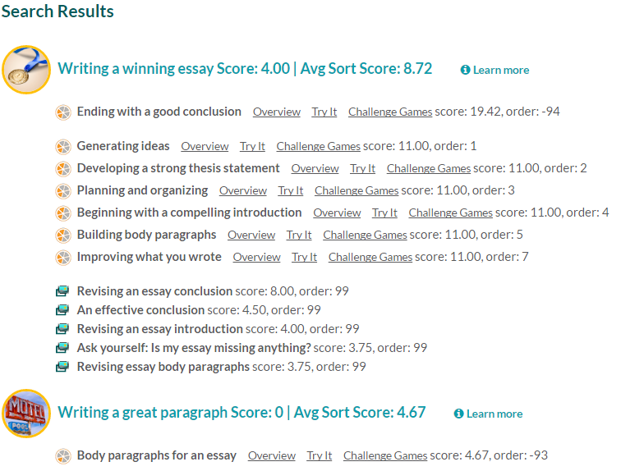

## View searchable attributes for a set of search results

You can also see details about what search attributes are contributing to the search results.

1. While logged in as Alistair, load this URL in the same browser:

[/juice/test_search](http://dev.juiceyourskills.com/juice/test_search)

1. Enter your search term in the query box and click Search.

The page will return the items that are found and the attributes that were searched:

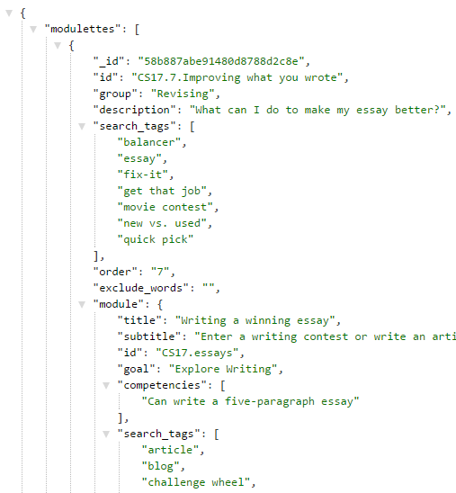

# Improving Search results

## Using tags to improve search results

If you enter a search term in the site and do not see the results you want, add the search term as a tag to either the module, modulette, or ancillary file.

Caution! A module’s relevance score will be affected by its own relevance as well as the relevance of the items that belong to it. Avoid adding the same tag to a modulette and a module. If the modulette is found, the module will display as well.

The JUICE team’s editorial practice is to add tags as follows:

* “Picture it” as a tag to all ancillary files
* Mini-game types to modulettes
* “challenge wheel” as a tag to any module with a Challenge Wheel game
* Try it contexts to modulettes
* Subject tags “math” or “writing” if these are not found in the modulette titles
* Alternate skill names

## Removing words that give unexpected results

The JUICE team’s editorial practice is to remove words that give unexpected results as follows:

* The item has an unexpected word in the title. For example, the modulette “Writing math expressions” excludes the word “Writing”
* The modulette is in a group with combined skills. For example, the modulette “Personal Pronouns” is in the Pronouns and Possessives modulette group. The modulette excludes the word “Possessives”

## Rubrics

JUICE has a set of rubric criteria that is mapped to each module, and also to some individual modulettes. You can use these rubric criteria, modify them, remove them, and add your own.

Bear in mind that if your rubric overlaps with any of the other searchable criteria, you will be adding weight to that item in the search results.  
  
The JUICE team’s editorial practice is not to worry about this. If the student is searching for an item using wording that occurs in one of our rubrics, most likely the item that is found is going to be the most relevant item anyway.

## Projects and Goals

The JUICE Dashboard includes a Goals and Projects view that maps modules to projects (assignments) and learning goals:

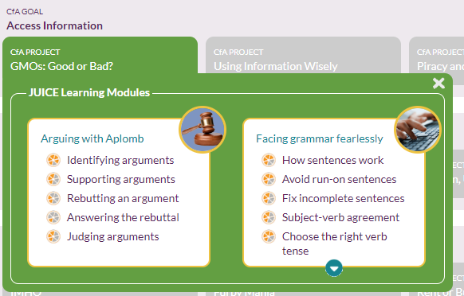

These can be renamed as appropriate for your program by editing this file:

/components/program-value/program-value-defaults.json

See the documentation on *Customizing basic UI components* for more information.

If you choose to use this view, the project/assignment names and their associated goal/unit/lesson name can be added to the search_modules collection. Searching on relevant projects and assignments was the most common use of Search by JUICE users.

## Tools for reviewing user search requests

You can review user search requests and use the results to modify search tags and improve search results. You have two views into what search terms are being used:

* If you have configured Google analytics, you can use the GA Search report to see a list of search terms used by all users.
* JUICE Searches report

This is a list of all the search terms users have tried, and includes their user id, and the results that JUICE returned. To access the JUICE Searches report:

1. Log in using the oauth test page and Alistair Admin as the user so that you are viewing the site with role = Admin
2. After you log in, put this in the URL:

[/juice/searches](http://www.juiceyourskills.com/juice/searches)

This will show you a list of the searches attempted by your users and what was found:

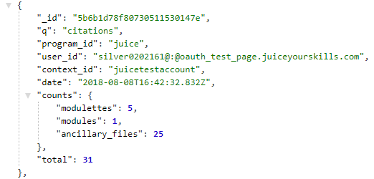

# Adding and removing content items from Search

The JUICE Search index tables are part of Mongo DB, and should have been added to your instance of Mongo DB when JUICE was installed on your server. The data is stored in three collections:

search_ancillary_files

search_modules

search_modulettes

If you wish to modify the ndexes to add, edit, or remove search tags or content items, update the appropriate **.bson** files in the **/public/data/mongo_data/dump/juice** directory and then run “restore dump.” See the directions in Git Hub for more information.